**Query for Problem:**

|  |
| --- |
| UPDATE LOCATION  SET LOCNAME = ‘Gate’  WHERE LOCNAME = ‘Door’; |

**Snapshot for the Problem:**

1. **Before Updating the query**

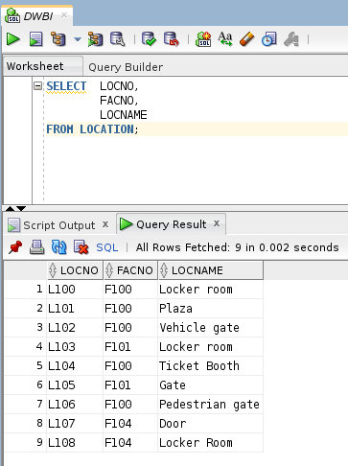

1. **Executing the Update query**

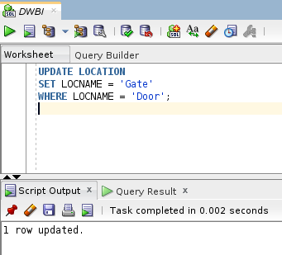

1. **After executing the query**